# Homework 5 Example Output

## Rachel Gully

## [rgully4@gmu.edu](mailto:rgully4@gmu.edu)

# Usage and Help Text



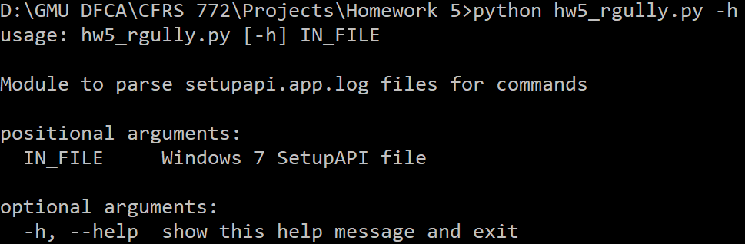

# Parsing Files Scenarios





